Traffic Analysis Dashboard – Final Report

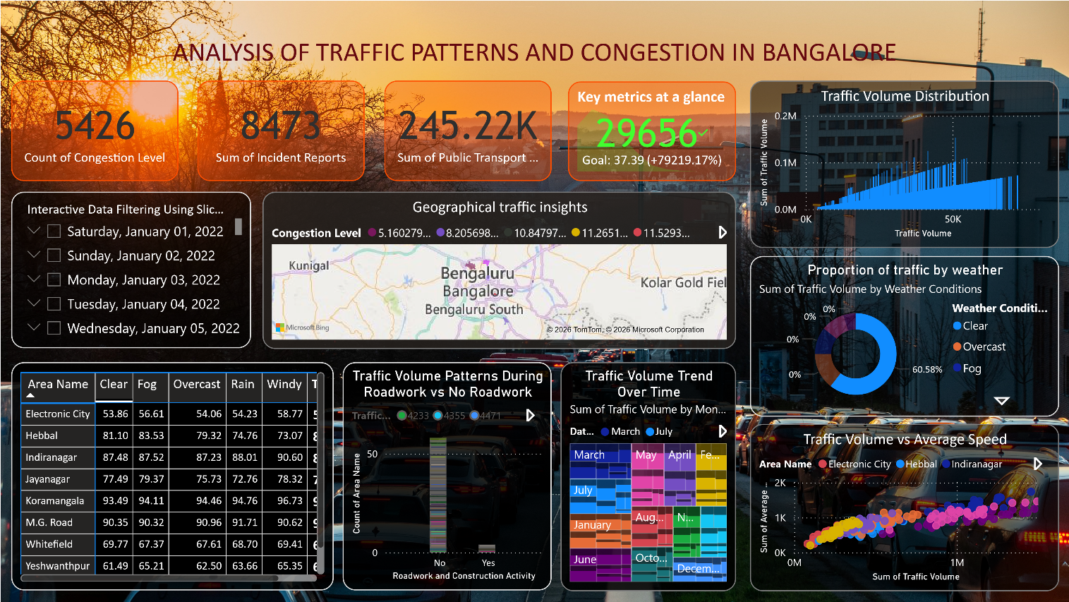
Dashboard Interpretation
This dashboard provides a comprehensive view of traffic patterns and congestion in Bangalore by combining traffic volume, congestion levels, incidents, public transport usage, weather conditions, roadwork impact, and geographic distribution.
At a glance, decision-makers can understand where traffic is highest, why congestion occurs, how external factors affect traffic, and how traffic changes over time.

What the Patterns Mean
- Areas with higher traffic volume consistently experience higher congestion and lower average speed.
- Roadwork and construction activities clearly worsen traffic conditions, increasing delays at intersections.
- Weather conditions, especially clear vs foggy conditions, show noticeable differences in traffic distribution.
- Traffic volume follows time-based patterns, indicating predictable peak periods.
- Certain areas repeatedly appear as traffic hotspots, showing long-term infrastructure stress.

Key Insights from the Traffic Dashboard
1. Traffic Volume Is High Even Without Severe Congestion
- The Traffic Volume Distribution shows consistently high vehicle counts across many roads.
- However, congestion levels are not always extreme, indicating that road capacity and traffic flow management are partially effective.
- This suggests that congestion is influenced by specific conditions rather than volume alone.

2. Average Speed Drops as Traffic Volume Increases
- The Traffic Volume vs Average Speed scatter plot shows a clear inverse relationship.
- As traffic volume increases, the average speed reduces significantly.
- Some areas like Electronic City and Indiranagar experience sharper speed drops, indicating bottlenecks or infrastructure limitations.

3. Roadwork Has a Direct Impact on Traffic Congestion
- The Roadwork vs No Roadwork chart shows noticeably higher traffic volume and congestion during road construction periods.
- Even a small amount of roadwork causes disproportionate delays, especially during peak hours.
- This highlights the importance of better roadwork scheduling and traffic diversion planning.

4. Weather Conditions Influence Traffic Flow
- The Weather-based traffic distribution reveals that:
  - Clear weather contributes to the highest traffic volume.
  - Rain and fog slightly reduce traffic volume but increase congestion and delays.
- Poor weather does not stop traffic but slows it down, increasing travel time and congestion.

5. Traffic Patterns Vary Significantly by Area and Time
- The map and monthly trend visuals show strong location-based and time-based variations.
- Certain areas consistently show higher congestion levels, making them traffic hotspots.
- Monthly trends indicate seasonal fluctuations, suggesting predictable traffic patterns that can be planned for.

Business & Decision-Making
- Optimize traffic signals in consistently congested areas.
- Schedule roadwork during off-peak hours to reduce disruption.
- Promote public transport usage in high-traffic zones.
- Deploy traffic police dynamically during peak congestion times.
- Use weather-based alerts for proactive traffic management

Final Story with the Dashboard
The dashboard tells a complete story of how traffic in Bangalore is shaped by multiple interconnected factors. High traffic volume alone does not always cause congestion; instead, congestion increases sharply when combined with roadwork, peak times, and unfavourable weather conditions. Average speed consistently drops as traffic volume rises, especially in high-demand areas. Geographical analysis reveals recurring congestion hotspots, while time-based trends highlight predictable seasonal patterns. Together, these insights emphasize the need for targeted traffic management strategies rather than one-size-fits-all solutions.

